APPENDIX

AI-Free Local File Search Assistant

A PROJECT REPORT

Submitted by:
Jay Kumar, Syed Faiz Hussain, Madhurya Dutta

in partial fulfillment for the award of the degree
of

Bachelor Of Technology
IN
Computer Science and Engineering



Lovely Professional University, Punjab

12419991, 12416409, 12403830

July 2026

1. Abstract

The growing amount of digital data on personal computers has made file searching crucial for users. Traditional file search methods often involve repeatedly going through directories, which becomes slow as the number of files increases. To solve this issue, SearchIt has been created as a local file search assistant that offers fast and efficient file searching without AI, using Data Structures and Algorithms (DSA).

The application is written in C++ and uses the Trie (Prefix Tree) data structure for accurate and prefix-based searches with better efficiency. First, the system scans a chosen directory, indexes all available files, and stores important details like file name, file path, extension, size, and last modified date. This indexed data allows for quick searches without having to go through the file system multiple times.

SearchIt offers various search methods, including Exact Search, Prefix Search, Case-Insensitive Search, Smart Search, and Extension-Based Search. It also features a metadata indexing system and a module for detecting duplicates. This module groups possible duplicate files based on their sizes using Hash Maps (unordered_map). These features enhance the application's usability while showcasing practical uses of key DSA concepts.

The project is built on a modular software architecture, consisting of separate components like the File Scanner, File Indexer, Trie, Search Engine, Ranking Module, and Duplicate Detector. This design improves maintainability and allows for future additions of advanced features such as graphical user interfaces, content-based searching, and hash-based duplicate detection.

The main goal of this project is to connect theoretical Data Structures to real-world software development by implementing efficient searching and indexing algorithms in a practical desktop application. It demonstrates the use of Tries, Vectors, Hash Maps, Sorting Algorithms, File System Traversal, and Metadata Management, making it not only an effective educational project but also a helpful desktop file search tool.

Keywords: Trie, Data Structures and Algorithms, File Indexing, Smart Search, Metadata Indexing, Duplicate Detection, C++, File System, Local Search Assistant.

2.1 Introduction

In today's digital world, computers store a vast amount of information, including documents, presentations, source code, images, videos, spreadsheets, and many other digital files. As the amount of stored data grows, finding a specific file becomes more difficult and time-consuming. Users often organize their files into multiple folders and directories, but remembering the exact location or filename can be challenging as time passes. Because of this, an effective file search system is essential for both personal and professional computer users.

Traditional file searching methods rely on scanning the directory structure every time a search is requested. While this method is effective for small collections of files, it becomes inefficient when thousands of files are stored across different folders. Each search operation requires repeated traversal of directories, which leads to longer search times and unnecessary computational overhead. This issue emphasizes the need for better searching techniques that can provide quick results without constant access to the file system.

Data Structures and Algorithms (DSA) play a key role in efficiently solving these problems. Proper data structures reduce search time, improve memory use, and enhance application performance. One of the most effective data structures for searching text data is the Trie (Prefix Tree). A Trie stores strings character by character, allowing for both exact and prefix-based searches with great speed. Unlike linear searching, the search time depends only on the length of the search query rather than the total number of files stored.

The project SearchIt was developed as a local file search assistant that does not rely on AI. It shows the practical use of Data Structures and Algorithms to solve a real-world problem. The application scans a chosen directory, indexes all available files, extracts useful metadata, and stores file information for efficient searching. The search engine supports Exact Search, Prefix Search, Case-Insensitive Search, Smart Search, Extension-Based Search, and Duplicate Detection. The project is built entirely in C++ using the Standard Template Library (STL) and the C++17 Filesystem Library.

Unlike many commercial search engines that rely on cloud services or artificial intelligence, SearchIt is a lightweight offline application that performs all operations locally. This leads to faster execution, improved privacy, and independence from internet connectivity. Additionally, the project follows a modular software architecture, making it easier to maintain, understand, and extend with future updates like graphical user interfaces, content indexing, and advanced duplicate detection.

The main goal of this project is not only to create a useful desktop application but also to showcase the practical applications of important DSA concepts such as Tries, Vectors, Hash Maps, Sorting Algorithms, File Indexing, and Metadata Management. The project serves as an educational example of how theoretical algorithms can be applied to real-world software systems.

2.2 Problem Statement
As the amount of digital information stored on personal computers continues to grow, searching for specific files using traditional methods becomes increasingly inefficient. Existing file searching methods repeatedly scan directories whenever a search operation is performed, resulting in higher execution time and reduced performance, particularly when dealing with large numbers of files.
Users often remember only a portion of the filename instead of its complete name or location. Conventional search techniques may fail to provide satisfactory results in such situations. Additionally, organizing and identifying duplicate files manually is both difficult and time-consuming.
Therefore, there is a need for a lightweight desktop application capable of indexing files, performing efficient searching, managing file metadata, and detecting duplicate files while demonstrating the practical use of Data Structures and Algorithms.

2.3 Objectives
The primary objectives of the project are:
- To develop a local desktop file search assistant using C++.
- To implement the Trie data structure for efficient searching.
- To perform exact and prefix-based file searching.
- To support case-insensitive searching.
- To develop a smart search mechanism capable of automatically selecting the appropriate search strategy.
- To scan directories and index all available files.
- To extract and store metadata including filename, path, file size, extension, and last modification time.
- To detect potential duplicate files using Hash Maps.
- To apply multiple Data Structures and Algorithms in a practical software project.
- To design a modular and scalable software architecture.

2.4 Scope of the Project
Scope of the current project involves developing an efficient local file searching system, which will help to make file searching on a computer an easier process. The system will be designed using the efficient combination of file indexing techniques and Data Structures and Algorithms. It will not traverse the directories for each search request, but will perform one scan of the selected directory, collect the information needed, and store it for future references.
The application is designed for several functions at the moment, namely directory scanning, file metadata indexing, exact search, prefix search, case insensitive search, smart search, extension search, and detection of duplicates. The File Scanner module is used for discovering all the files in the selected directory, whereas File Indexer extracts metadata like file name, file path, file size, file extension, and the last modified date from the files.
Trie Data Structure is used to facilitate efficient searching and prefix searching to reduce the time spent on searching drastically in comparison with linear searching methods. The Smart Search feature helps in choosing the optimal search method depending on the query raised by the user. Moreover, the duplicate files detection feature uses Hash Maps to group files that have similar file size to help users locate potential duplicate files easily.
The project is written in C++ language and follows modular software design. The present version of the project mainly provides functionality for searching by filenames only but gives an opportunity to apply Data Structures and Algorithms in practice. Future versions of this application can include such improvements as GUI, searching of file contents, advanced duplicate files detection using hashing algorithms, searching history, cloud synchronization, and multimedia files preview.

2.5 Applications
SearchIt is an efficient desktop file search software that can be used in various scenarios requiring effective file storage and search. Scanning, indexing, and searching of files make SearchIt very useful not only to individuals but to organizations as well. Some of the main uses of SearchIt include the following:
1. File Management of Personal Computers: SearchIt helps individuals manage and find their personal files like documents, pictures, videos, songs, and presentation files. Instead of navigating through different folders one by one to find any particular file, users can do a quick search of their files by name, prefix or extension.
2. Educational Institutions: There are many students, teachers, and researchers that store large numbers of lecture files, assignments, research papers, and presentations. SearchIt helps to search through the files faster and effectively.
3. Office and Corporate Environment: Businesses often keep a vast number of reports, agreements, invoices, spreadsheets, and other corporate documentation. SearchIt allows employees to perform quick and easy file searches to increase efficiency and save time on document access.
4. Software Development Projects: Software engineers usually work with thousands of source code files stored in various project folders. With SearchIt, one can easily find specific source files, configuration files, documentation, and other project resources by their filenames or file extensions.
5. Digital Libraries: A digital library is a collection of electronic publications such as books, articles, journals, scientific papers, and other reference materials. SearchIt makes organizing and searching through such resources possible due to its ability to index files and perform fast searches.
6. Document Management System: Companies storing electronic documentation may use SearchIt as an alternative search engine to speed up the document search process and get access to necessary documents through metadata indexing.
7. Local Storage and Backup Management: In most cases, people keep their backups in various storage devices like hard disks, solid state disks, and external storage media. The use of SearchIt helps locate stored files, find out duplicated files, and manage their data effectively.
On the whole, SearchIt is an effective and scalable tool for any application where quick and efficient local file search is necessary. The modularity of SearchIt makes it suitable for larger applications like document management systems, digital asset management, and desktop search utilities.
2.6 Advantages
However, the SearchIt system possesses many advantages compared to traditional file searching by incorporating Efficient Data Structures and Algorithms in its implementation as well as having an efficient software architecture. The main advantages of the system are given below:
1. Faster Searching: SearchIt is much faster than traditional file searching methods because it indexes file information before the search process begins. This way, there is no need for the repeated scanning of directories which takes much time.

2. Efficient Trie Data Structure Implementation: SearchIt employs the Trie (prefix tree) data structure that stores filenames effectively which makes possible fast searching using both exact and prefix methods.
3. Multiple Searching Methods: The program allows for Exact, Prefix, Smart, Extension, and Case-insensitive Search. This feature improves the usability of the software as it lets users use multiple ways of searching for files.
4. Case-Insensitive Searching: Searching for the files does not depend on whether characters are written in uppercase or lowercase letters, which makes the program easy to use.
5. Duplicates Files Detection: SearchIt finds potentially duplicate files through putting together files of identical size in Hash Maps.
6. Metadata Extraction: The application extracts essential metadata such as name of the file, file path, extension, file size, and date of last modification. These details can be leveraged to improve filtering, sorting and further enhancement of the application.
7. Modular Software Design: Every part of the application starting from File Scanner to File Indexer, Trie, Search Engine and Duplicate Finder have been separately programmed. Such modular design makes it easy to maintain, debug and further develop.
8. DSA Practical Implementation: This application showcases the practical use of several important Data Structures and Algorithms like Tries, Vectors, Hash Maps, File System Navigation, and Object Oriented Programming.
9.Operation Offline: SearchIt works only offline using the resources of the local computer. Thus making its operation faster, providing increased privacy and security of the users' files.
In summary, SearchIt is a fast and efficient software for searching through local files and showcasing the practical implementation of Data Structures and Algorithms in a modern day desktop application.
3. Algorithm
3.1 File Scanning Algorithm
Objective
The File Scanner module scans the selected directory and gets the names of all files in it. The C++17 Filesystem Library is used to efficiently go through the directory. The scanner does not check the file contents; it only identifies all files that will be indexed later.
Algorithm
- Start the program.
- Accept the directory path from the user.
- Initialize the File Scanner.
- Traverse the directory using the Filesystem library.
- For each file encountered:
  - Read its filename.
  - Store the filename in a vector.
- Continue until all files have been scanned.
- Return the list of filenames.
- End.

Time Complexity
Operation | Complexity
Directory Traversal | O(n)
where n is the number of files.

3.2 File Indexing Algorithm

Objective

After scanning the directory, every file is indexed by storing its metadata. The metadata includes filename, complete path, file size, extension, and last modified time.

Algorithm

- Receive the list of scanned files.
- For each file:
  - Generate complete file path.
  - Read file size.
  - Read file extension.
  - Read last modification time.
- Create a FileInfo object.
- Store all metadata.
- Add FileInfo to the indexed list.
- Return indexed files.

Time Complexity
Operation | Complexity
Metadata Extraction | O(n)

3.3 Trie Insertion Algorithm
Objective
The Trie stores filenames character by character, enabling efficient exact and prefix searching.
Algorithm
- Start from the root node.
- Read each character of the filename.
- If a child node does not exist:
  - Create a new node.
- Move to the next node.
- Repeat until all characters are inserted.
- Mark the final node as the end of the word.

Time Complexity
Operation | Complexity
Insertion | O(L)
where L is the filename length.

3.4 Exact Search Algorithm
Objective
Search for filenames that exactly match the user's query.
Algorithm
- Convert query to lowercase.
- Start at the root.
- Compare every character.
- If any character is missing:
  - Return "File Not Found".
- If the last node is reached:
  - Return file path.
Time Complexity
Operation | Complexity
Search | O(L)

3.5 Prefix Search Algorithm
Objective
Return every filename beginning with a given prefix.
Algorithm
- Convert prefix to lowercase.
- Traverse the Trie.
- Reach the prefix node.
- Perform DFS from that node.
- Collect every complete filename.
- Return results.

Time Complexity
Operation | Complexity
Prefix Search | O(L + k)
where:
- L = prefix length
- k = number of matching files

3.6 Smart Search Algorithm
Objective
Automatically determine the best searching strategy.
Algorithm
- Convert query to lowercase.
- Perform Exact Search.
- If found:
  - Return results.
- Otherwise:
  - Perform Prefix Search.
- If no results:
  - Perform Extension Search.
- Display final results.

Time Complexity
Worst Case
Operation | Complexity
Smart Search | O(L + k)

3.7 Duplicate Detection Algorithm
Objective
Detect files that potentially have duplicate copies using file size.
Algorithm
- Read indexed files.
- Create a Hash Map.
- Use file size as the key.
- Store files having the same size together.
- If more than one file exists for a key:
  - Mark as duplicate group.
- Display duplicate groups.

Time Complexity
Operation | Complexity
Duplicate Detection | O(n)

3.8 Overall System Algorithm
This summarizes the complete workflow of the project.
Algorithm
- Read directory path.
- Scan files.
- Index file metadata.
- Insert filenames into Trie.
- Accept user query.
- Perform Smart Search.
- Display matching results.
- Detect duplicate files.
- Display duplicate groups.
- Exit.

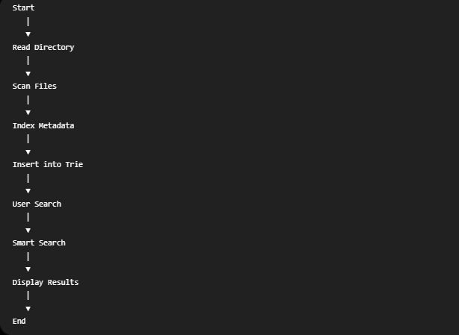
4. Results
4.1 Exact Search
The Exact Search module returns files whose filenames exactly match the user's query.

Sample Output:
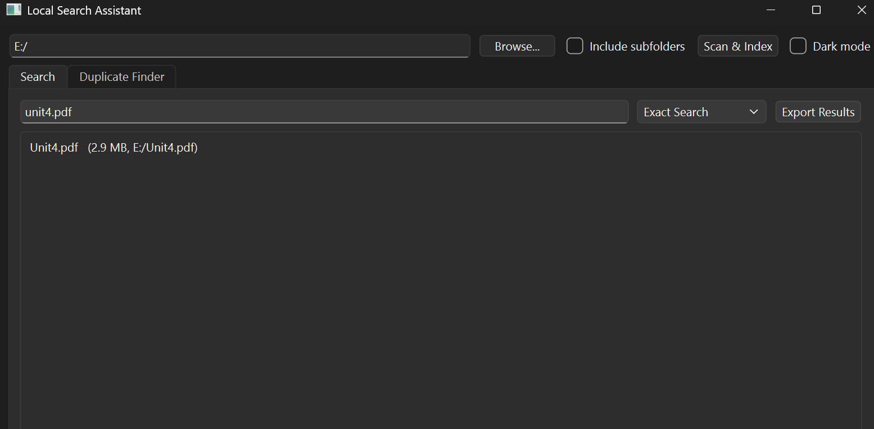

Result Analysis
The application correctly identified the file whose filename exactly matched the search query.

4.2 Duplicate Detection
The Duplicate Detector groups files that have identical file sizes.

Sample Output:
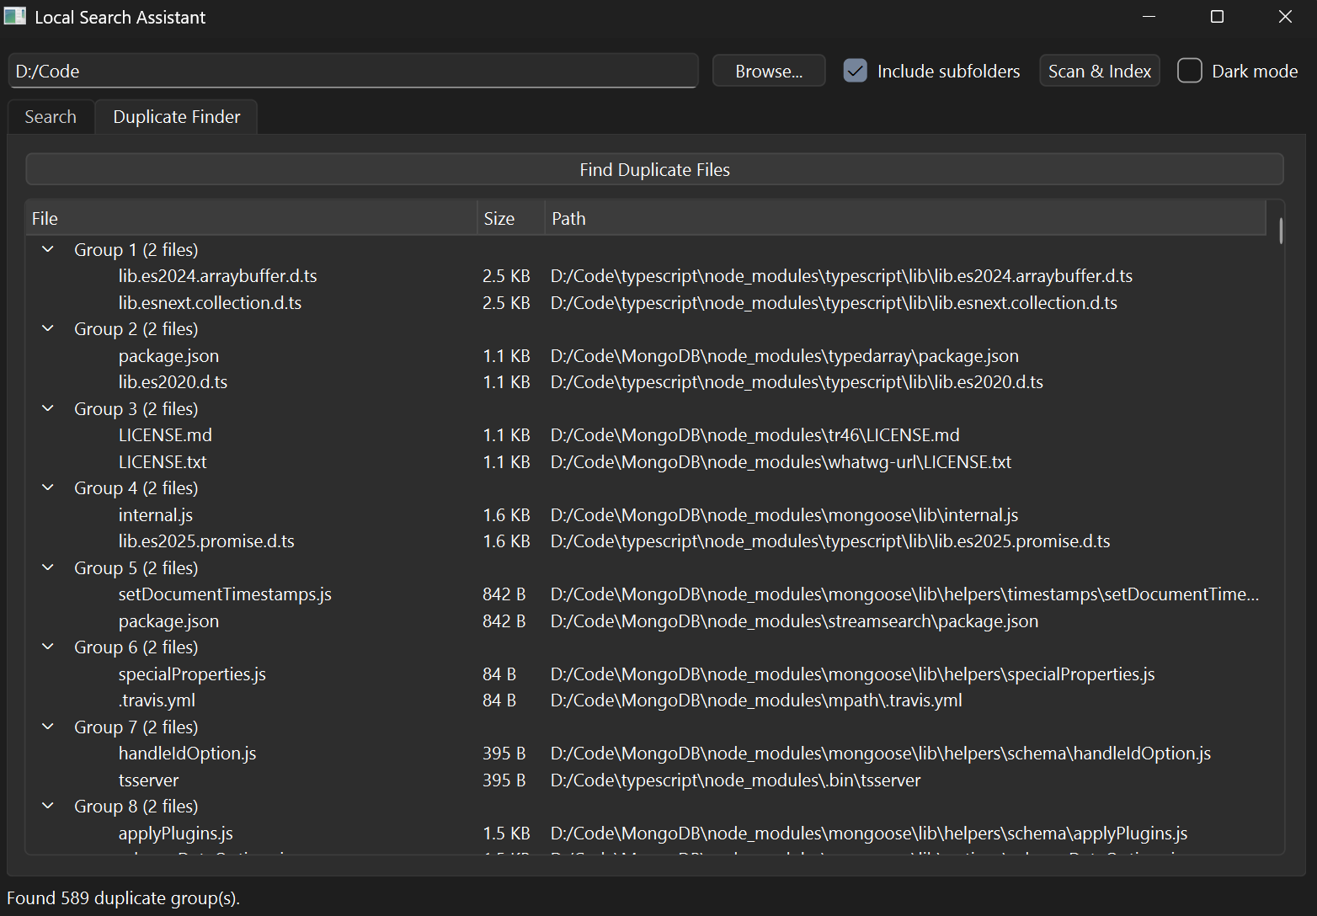
Result Analysis
The Duplicate Detection module successfully grouped files with identical sizes using a Hash Map. These files are marked as potential duplicates.

4.3 Case-Insensitive Search
Case-insensitive searching allows users to search without worrying about uppercase or lowercase characters.

Sample Output:
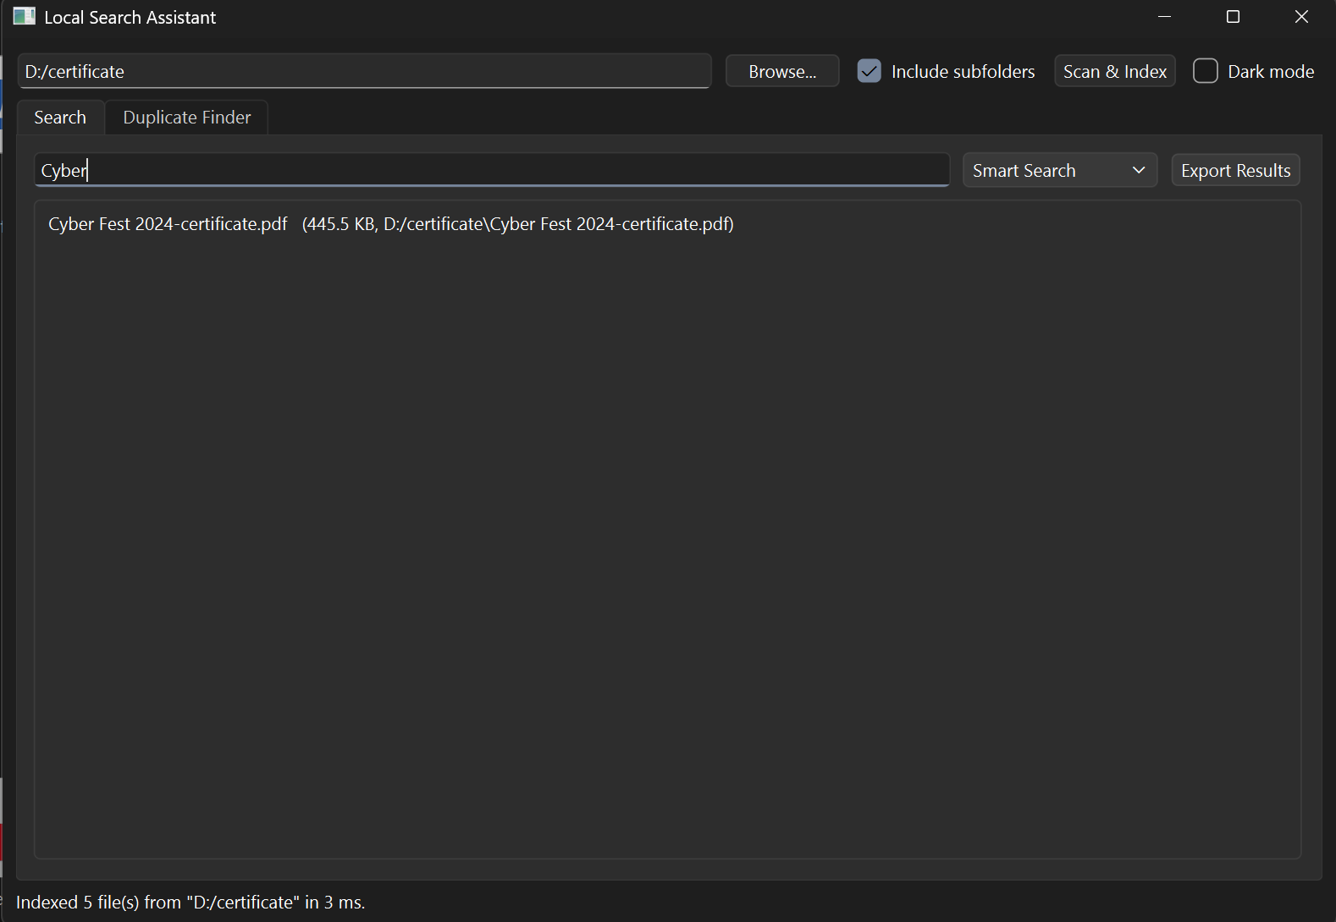

Result Analysis
The query was converted to lowercase before searching, enabling successful retrieval regardless of the user's input format.

4.4 Overall Performance
SearchIt, the proposed system, brings a lot of benefits compared to the traditional file searching techniques due to the implementation of efficient Data Structures and Algorithms in a modular way in the software development approach. The main goal of the application is to make file searching fast, accurate and reliable. The following list presents some of the most important benefits of the system:
1. Faster File Searching: SearchIt makes the file searching process much faster since it pre-indexes files and searches for files based on the indexed data. It does not need to go through folder after folder in order to find the files like other traditional approaches.

2. Efficient Trie-based File Searching: In order to achieve efficient string searching in the system, the Trie (Prefix Tree) Data Structure is used. This provides for efficient exact and prefix-based searching of thousands of files.
3. Various Search Methods: SearchIt offers several types of file searching methods: Exact Search, Prefix Search, Smart Search, Extension-based Search and Case-Insensitive Search.
4.Search Insensitive to Case: The program first converts both the filenames and the user query to the same form before performing the search. This allows the user to find the files regardless of whether the name is in upper case or lower case.
5.Detection of Duplicate Files: There is a duplicate detector component of SearchIt that detects duplicate files based on their file size by use of Hash Maps (unordered_map).
6.File Metadata Management: The program collects important file metadata such as filename, full pathname, file size, file extension, and file modification date. This enhances the accuracy of searches and lays the basis for future filtering and sorting functions.
7.Software Architecture Modularity: All the components such as the File Scanner, File Indexer, Trie, Search Engine, Ranking Module, and Duplicate Detector work independently. This makes the system easy to test, debug, maintain, and enhance in the future.
8.Educational Purpose: This project shows practical applications of some important Data Structures and Algorithms such as Tries, Vectors, Hash Maps, and file system traversal.
9. Local Processing: SearchIt processes all tasks locally without needing an internet connection. This makes its execution faster, enhances user privacy, and avoids any dependency on cloud solutions.
In conclusion, SearchIt is a very efficient application that offers speedy, secure, scalable, and effective search facility for local files while showing the real world application of modern Data Structures and Algorithms.

Performance Summary
Feature | Status
File Scanning | ✅ Successful
Metadata Indexing | ✅ Successful
Exact Search | ✅ Successful
Prefix Search | ✅ Successful
Smart Search | ✅ Successful
Case-Insensitive Search | ✅ Successful
Duplicate Detection | ✅ Successful

5. Conclusion
The SearchIt project shows how to use Data Structures and Algorithms in a real-world desktop application. The application efficiently searches local files using a Trie data structure. This approach greatly improves search performance compared to traditional directory navigation. By indexing file metadata in advance, the system allows for fast and accurate file retrieval while reducing repeated access to the file system.

The project combines several DSA concepts, including Tries, Vectors, Hash Maps, Sorting Algorithms, and File System Traversal, in a modular software design. Additional features like case-insensitive searching, smart search, metadata indexing, and duplicate detection improve the application's usability and effectiveness.

From an educational standpoint, the project offers hands-on experience in object-oriented programming, modular software development, and efficient searching algorithms. It shows how theoretical ideas from Data Structures and Algorithms can be turned into a useful software tool.

Future improvements might include a graphical user interface using Qt, content-based file searching, hash-based duplicate detection, advanced filtering options, and support for more file formats. Overall, SearchIt works well as both a learning project and a practical local file search tool.

6. References
Books
- Reema Thareja, Data Structures Using C++, Oxford University Press.
- Thomas H. Cormen, Charles E. Leiserson, Ronald L. Rivest, and Clifford Stein, Introduction to Algorithms (CLRS), MIT Press.
- Stanley B. Lippman, Josée Lajoie, and Barbara E. Moo, C++ Primer, Addison-Wesley.
Websites
- https://en.cppreference.com
- https://cplusplus.com
- https://learn.microsoft.com/cpp
- https://gcc.gnu.org
- https://isocpp.org

Code Snippets:

